**OBSERVABLE TRENDS BASED ON DATA**

1.Out of the total **576** players, number of male players dominate the number of female players by a large amount. The number of male players is **484(84 %)** while the number of female players is just **81(14%)**

Fig1. Total count vs Gender

Although the number of male players is larger than the number of female players yet the **Average total per person** for female is greater than the male. For female the **Average total per person** is **$4.47** while for male it is slightly lower, **$4.07**.

2.After binning on the age it is clearly seen that the age group between **20 to 24** has the total largest count of players **(44.79%).** There are small number of players in the age group **40+( 2.08%).**

The average total per person is not so much dependent on the age bins

Fig2.Percentage of players based on age bins

3.The data also shows the list of the top spenders. **Lisosia93** from age group of **25 – 29** is the largest spender. Digging deeper we find that there is no relation between the highest spender and the most popular item.

Oathbreaker, Last Hope of the Breaking Storm is the most popular item as well as the most profitable item with total purchase value of **50.76$**

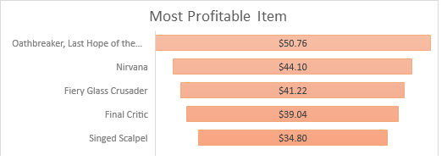

Fig3 Most Profitable Item